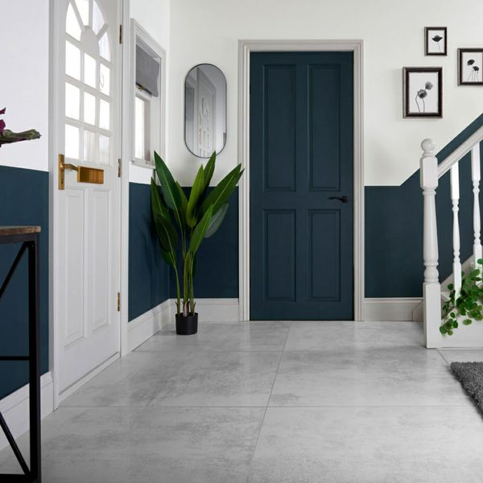**Cosmic Cloud White Lappato Floor Tiles:**

## **Product Description**

Go for a contemporary, industrial style with these Cosmic Cloud White Lappato 898x898 Tiles! They feature a metallic look that is a striking feature for modern interior design in any room. With a lappato finish and unique rusted illusion, they add texture and dimension instantly across wall and floor spaces.

**What's special about these tiles?**

> Unique rusted look for a textured design

> Semi-polished, lappato finish

> Metallic feel

> Large format design

> Durable porcelain body

**Try before you buy**

If you'd like to take a closer look, why not order a sample tile? Samples are a great way to get a feel for a tile's true colour and texture, and you can see how it looks in your chosen room!

## **Product INFO**

* Product ID: 44767
* Tiles Per SQM: 1.2400732139225
* Sale by: Per SQM
* Size: 898x898x10mm
* Weight: 19.30 KG
* Material Type: Porcelain
* Finish: Semi-Polished
* Colour: White
* Suitability: Floors, Walls
* Grade: 4
* Rectified Edge: No
* Underfloor Heating: Yes
* Thickness (mm): 10